**WIRELESS TELE-OPERATION OF A ROBOTIC HAND WITH**

**HAPTIC FEEDBACK TECHNOLOGY**

**ABSTRACT**

Automation is an ever-growing trend in today’s industry. By establishing a strong human-machine interaction, humans can advance further in their journey of making lives easier. The main aim of our project is to design an intelligent data glove to control a wireless robotic hand with haptic feedback. This data glove can be practically linked to any system to form a control unit that can be manipulated over a wide range. The robotic hand introduces the haptic feedback technology by adding pressure sensors on the fingertips of the robotic hand. The feedback system will allow the user to sense their environment with some form of sensation enabling them to get a better feel of reality. The feedback selected is the haptic where the user putting on the glove will feel touch sensations if the end-effector touches something. Practically a distance of 90 feet is viable for operation.

The sensor glove has sensors and Arduino microcontroller embedded onto it. The actions done by the user will be sensed by flex sensors and Arduino will process the information. The IDE used for doing the software is Arduino’s own IDE called Arduino. On the receiver’s side is a robotic hand that will mimic the actions of the sensor glove over finite degrees of freedom (DOF). The wireless communication protocol used between the glove and robotic hand is ZIGBEE. This protocol enables to have mesh-network systems and transmit data over a longer distance giving the sensor glove a wider range to communicate with the robotic hand. The robotic hand senses pressure on its own finger tips and palm and gives the readings to the sensor glove. Apart from sensors, the sensor glove also has vibration motors that vibrate if the robotic hand’s force sensors feel any force – thus generating touch-feedback mechanism.

**2. Operating Principle**

The basic operating principle used in robotic hand is movement of servomotors with the increase or decrease in resistance accordingly and for the feedback, the increase in resistance operates the vibration motor.

**2.1: Block Diagram:**

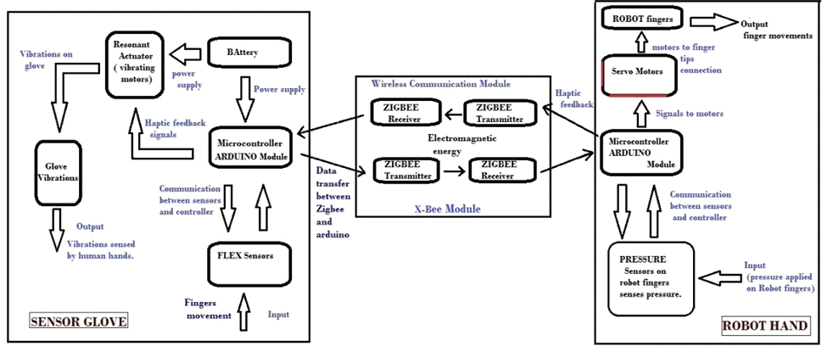

Figure.2.1: Block diagram of wireless robotic arm with haptic feedback

As fingers move and the flex sensors bend and this is given to the Arduino Uno module present at the glove from where it is transmitted to another Arduino Uno module present at the robot’s hand through ZIGBEE wireless communication module. With the Arduino Uno module at the robot’s hand, the servo motors are operated and the robotic hand moves according to the movement of our hand.

The haptic feedback comes from the robotic hand to the glove. When the force sensing resistors (placed on the robotic hand) senses pressure it gives the pressure as an input to the Arduino Uno module and through the ZIGBEE it is sent to the glove Arduino Uno module. From here it is given to the linear resonant actuator present on the glove and according to the intensity of the applied pressure on the robotic arm the actuator vibrates.

A continuous supply of 5 volts is to be provided to both the Arduino Uno modules at the robot arm as well as the sensor glove.

**3. Circuit Diagram**

The transmitter circuit which shows the connection of ZIGBEE module and Flex sensors to the Arduino Uno board:

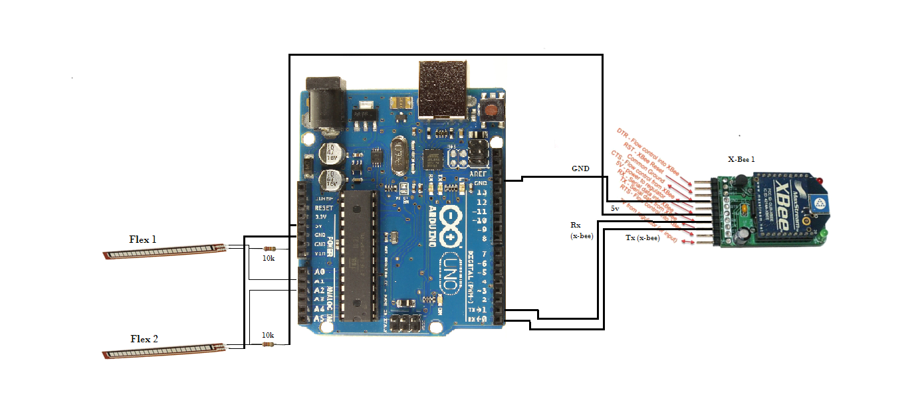

Figure3.1: Arduino Uno with flex sensors and XBee module

The receiver circuit which shows the connection of ZIGBEE module and servomotors to the Arduino Uno board:

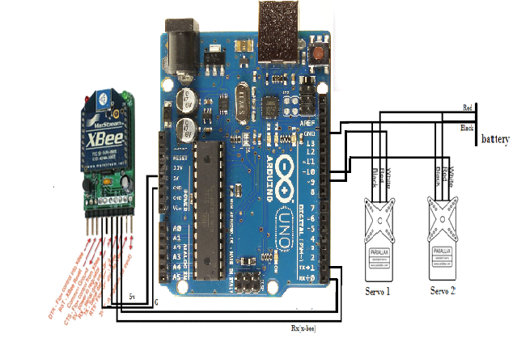

Figure3.2: Arduino Uno with servomotors and XBee module

**4. COMPONENTS USED**

**4.1.1 Arduino Uno Board:**

Arduino is an open-source electronics prototyping platform based on flexible, easy-to-use hardware and software. Arduino can sense the environment by receiving input from a variety of sensors and can affect its surroundings by controlling lights, motors, and other actuators. The microcontroller on the board is programmed using the Arduino programming language (based on Wiring) and the Arduino development environment (based on Processing).

The Arduino Uno is a microcontroller board based on ATmega328 (datasheet). The Atmel 8-bit AVR RISC-based microcontroller combines 32 KB ISP flash memory with read-while-write capabilities, 1 KB EEPROM, 2 KB SRAM, 23 general purpose I/O lines, 32 general purpose working registers, three flexible timer/counters with compare modes, internal and external interrupts, serial programmable USART, a byte-oriented 2-wire serial interface, SPI serial port, 6-channel 10-bit A/D converter (8-channels in TQFP and QFN/MLF packages), programmable watchdog timer with internal oscillator, and five software selectable power saving modes. The device operates between 1.8-5.5 volts. The device achieves throughputs approaching 1 MIPS per MHz It has 14 digital input/output pins of which 6 can be used as PWM outputs), 6 analog inputs, a 16 MHz ceramic resonator, a USB connection, a power jack, an ICSP header, and a reset button. It contains everything needed to support the microcontroller; simply connect it to a computer with a USB cable or power it with a AC-to-DC adapter or battery to get started. The ATmega328 is commonly used in many projects and autonomous systems where a simple, low-powered, low-cost micro-controller is needed. Perhaps the most common implementation of this chip is on the popular Arduino development platform, namely the Arduino Uno and Arduino Nano models. The ATmega328 has 32 KB (with 0.5 KB used for the bootloader). It also has 2 KB of SRAM and 1 KB of EEPROM. The Arduino Uno can be powered via the USB connection or with an external power supply. The power source is selected automatically.

The board can operate on an external supply of 6 to 20 volts. If supplied with less than 7V, however, the 5V pin may supply less than five volts and the board may be unstable. If using more than 12V, the voltage regulator may overheat and damage the board. The recommended range is 7 to 12 volts.

The following are the power pins:

**VIN**: The input voltage to the Arduino board when it's using an external power source (as opposed to 5 volts from the USB connection or other regulated power source). You can supply voltage through this pin, or, if supplying voltage via the power jack, access it through this pin.

**5V**: This pin outputs a regulated 5V from the regulator on the board. The board can be supplied with power either from the DC power jack (7 - 12V), the USB connector (5V), or the VIN pin of the board (7-12V). Supplying voltage via the 5V or 3.3V pins bypasses the regulator and can damage your board. We don't advise it.

**3V3**: A 3.3-volt supply generated by the on-board regulator. Maximum current draw is 50 mA.

**GND**: Ground pins.

**IOREF**: This pin on the Arduino board provides the voltage reference with which the microcontroller operates. A properly configured shield can read the IOREF pin voltage and select the appropriate power source or enable voltage translators on the outputs for working with the 5V or 3.3V.

**Features:**

|  |  |
| --- | --- |
| Microcontroller | ATmega328 |
|  |  |
| Operating Voltage | 5V |
| Input Voltage (recommended) | 7-12V |
| Input Voltage (limits) | 6-20V |
| Digital I/O Pins | 14 (of which 6 provide PWM output) |
| Analog Input Pins | 6 |
| DC Current per I/O Pin | 40 mA |
| DC Current for 3.3V Pin | 50 mA |
| Flash Memory | 32 KB (ATmega328) of which 0.5 KB used by bootloader |
| SRAM | 2 KB (ATmega328) |
| EEPROM | 1 KB (ATmega328) |
| Clock Speed | 16 MHz |
| Length | 68.6 mm |
| Width | 53.4 mm |
| Weight | 25 g |

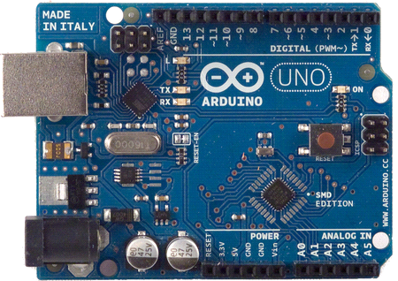

Fig.4.1: Arduino Uno Board

**4.2. ZIGBEE Module**

The ZIGBEE is the name of a wireless protocol maintained by the IEEE 802.15 standard. This is a protocol specified for wireless Personal Area Network (PAN) using low powered wireless transceivers. The XBee is the brand name a wireless transceiver device introduced by the Digi international which works on the ZIGBEE protocol and can form PAN networks. They have an approximate range of 10 to 100 meters and are used in industries, scientific fields, medical fields etc.

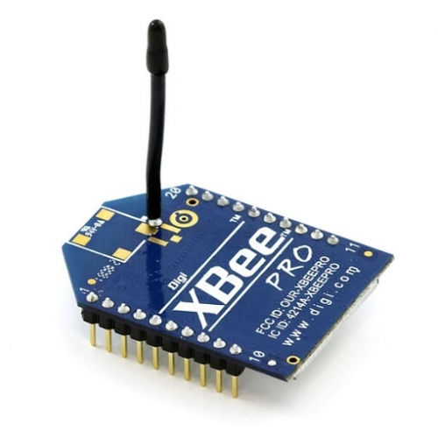

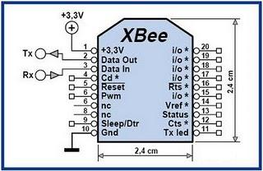

Figure 4.2.Pin configuration of XBee

The XBee module even though uses complex packet data based ZIGBEE protocol for communicating with each other, they can communicate with other devices using simplest serial communication protocol and hence they are widely used in microcontroller base boards. The goal IEEE had when they specified the IEEE 802.15.4 standard was to provide a standard for ultra-low complexity, ultra-low cost, ultra-low power consumption and low data rate wireless connectivity among inexpensive devices. The raw data rate will be high enough (maximum of 250 kb/s) for applications like sensors, alarms and toys.

IEEE 802.15.4 networks use three types of devices:

• The network Coordinator maintains overall network knowledge. It is the most sophisticated one of the three types and requires the most memory and computing power.

• The Full Function Device (FFD) supports all IEEE 802.15.4 functions and features specified by the standard. It can function as a network coordinator. Additional memory and computing power make it ideal for network router functions or it could be used in network-edge devices (where the network touches the real world).

• The Reduced Function Device (RFD) carries limited (as specified by the standard) functionality to lower cost and complexity. It is generally found in network-edge devices. The RFD can be used where extremely low power consumption is a necessity.

**Star network formation**

The first FFD that is activated ay establish its own network and become a Personal Area Network (PAN) coordinator. Then both FFD and RFD devices can connect to the PAN coordinator. All networks within the radio sphere of influence must have a unique PAN identity. All nodes in a PAN must talk to the PAN Coordinator.

**Peer-to-Peer network formation**

In the peer-to-peer topology there is also a PAN coordinator, but it differs from the startopology in that any device can communicate with any other device as long as they are in the range of one another. The peer-to-peer topology allows more complex network formations to be implemented, such as the mesh topology.



Figure 4.3: ZIGBEE Networking

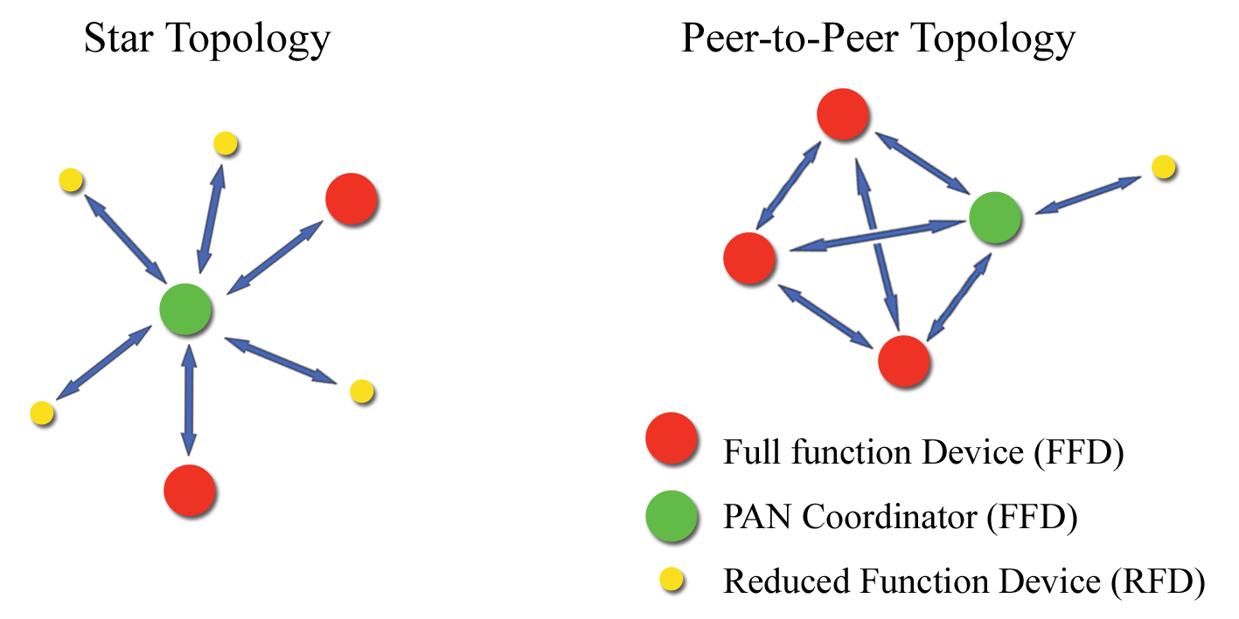Figure 4.4: Types of ZIGBEE networking

ZIGBEE can use so-called mesh networking, which may extend over a large area and contain thousands of nodes. Each FFD in the network also acts as a router to direct messages. The routing protocol optimizes the shortest and most reliable path through the network and can dynamically change, to take evolving conditions into account. This enables an extremely reliable network, since the network can heal itself if one node is disabled. This is very similar to the redundancy employed in the Internet. A new network node may be recognized and associated in about 30 ms. Waking up a sleeping node takes about 15 ms, as does accessing a channel or transmitting data. ZIGBEE applications benefit from the ability to quickly attach information, detach, and go to deep sleep, which results in low power consumption and extended battery life. You can use any of the standard Arduino serial commands with the Xbee shield. With the switch in the Micro position, the print and println commands will send data over the XBee shield and the USB connection (i.e. to other Xbee shields and to the computer at the same time). In this configuration, however, the board will only receive data from the XBee shield not from the USB connection.

The XBee module on the shield is set up to work at 9600 baud by default, so unless you reconfigure it, you'll need to make sure you're passing 9600 to the Serial.begin() command in your sketch.

To allow your computer to communicate directly with the XBee shield, connect it to an Arduino board whose microcontroller has been removed and place the switch in the USB configuration. Then you can send data to and receive data from the XBee module from any terminal program. This allows you, for example, to see the data that the module is receiving from other XBee shields

You can configure the XBee module from code running on the Arduino board or from software on the computer. To configure it from the Arduino board, you'll need to have the switch in the Micro position. To configure it from the computer, you'll need to have the switch in the USB position and have removed the microcontroller from your Arduino board.

To get the module into configuration mode, you need to send it three plus signs: +++ and there needs to be at least one second before and after during which you send no other character to the module. Note that this includes newlines or carriage return characters. Thus, if you're trying to configure the module from the computer, you need to make sure your terminal software is configured to send characters as you type them, without waiting for you to press enter.

Otherwise, it will send the plus signs immediately followed by a newline (i.e. you won't get the needed one second delay after the +++). If you successfully enter configuration mode, the module will send back the two characters 'OK', followed by a carriage return. This technology can be used to provide advanced temperature control, smart lighting and assist in the controllability or automation of numerous other household functions including music and television controls etc. An example of this would be the embedding on a ZIGBEE radio in the electric meter and thermostat. This would enable the user to have the lights automatically turn off as the more expensive rates go on even if they are not at home. The consumer could of course override this if at home. Other uses in this area include the general monitoring of energy consumption in the home. This technology could be used to alert the consumer of smoke or intruders detected in their home. This technology can be used to track tagged assets to their exact location. Uses for this include company stock rooms, supermarkets where consumers can easily locate the section containing their desired products. This technology could also help users locate lost assets. Commercial applications include access control, energy monitoring and lighting, process control, machine-to-machine (M2M) communication and industrial device control. Mobile healthcare, which allows medical practitioners to bring up and verify correct information about their patients in real time and allows the real-time modification of information as required is an important use. Other mobile uses include monitoring and control, security and access control.

X-CTU Configuration and Test Utility Software:

X-CTU is a windows-based application provided by Digi. This program was designed to interact with firmware files found on Digi’s RF products and to provide a simple-to-use graphical user interface to them. X-CTU is designed to function with all windows-based computers running Microsoft Windows 98 SE and above. X-CTU can either be downloaded from Digi’s website or an installed CD.

When launched, we will see four tabs across the top of the program. Each of these tabs has a different function. The four tabs are:

* PC Settings: Allows a customer to select the desired COM port and configure that port to fit the radio settings.
* Range Test: Allows a customer to perform a range test between two radios.
* Terminal: Allows access to the computers COM port with a terminal emulation program. This tab also allows the ability to access the radios’ firmware using AT commands.
* Modem Configuration: Allows the ability to program the radios’ firmware settings via a graphical user interface. This tab also allows customers the ability to change firmware versions.

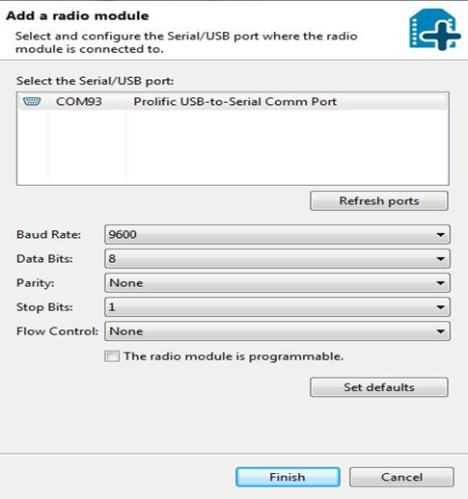

Figure 4.5: X-CTU configuration page

The PC settings tab allows the user to select a COM port and configure the selected COM port settings when accessing the port. Some of these settings include:

* Baud Rate: Both standard and non-standard
* Flow Control: Hardware, software (Xon/Xoff), none
* Data Bits: 4,5,6,7 and 8 data bits
* Parity: None, odd, even, mark and space
* Stop Bits: 1, 1.5 and 2

The change any of the above settings, select the pull-down menu on the left of the value and select the desired setting. To enter a non-standard baud rate, type the baud rate in the baud rate box to the left. The Test/Query button is used to test the selected COM port on PC settings. If the settings and COM port are correct, you will receive a response with a serial number.

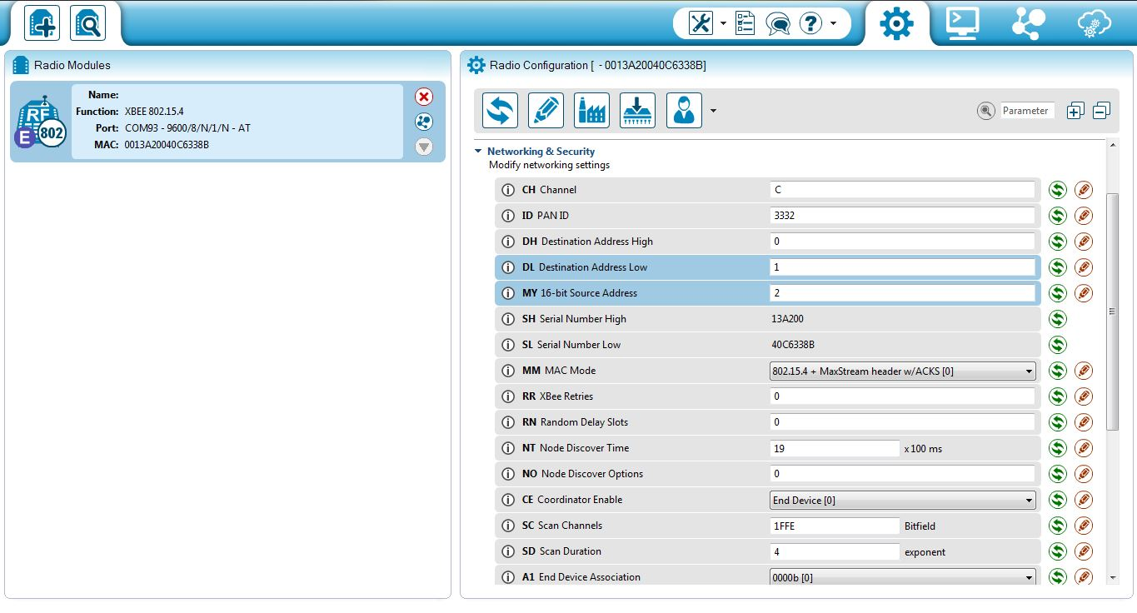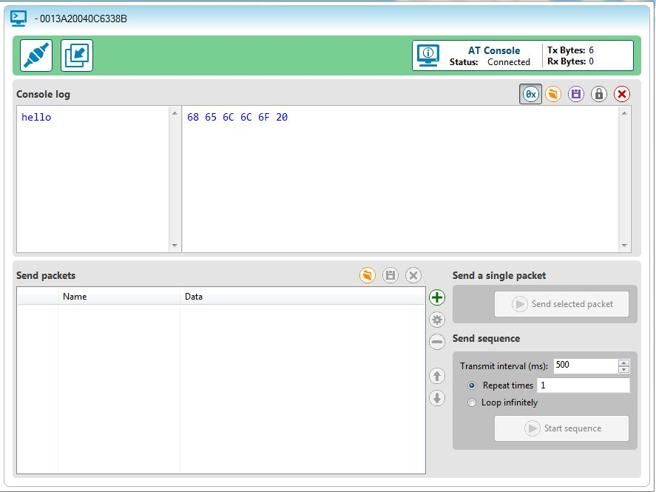

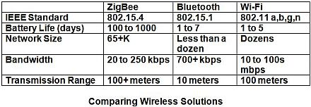

Table 4.1 Comparison of various networking model

**4.3 Sensors and Actuator:**

The sensors and actuator used in fabricating a wireless tele-operated robotic hand with haptic feedback technology are given below.

**4.3.1 Servomotor:**

Servos have integrated gears and a shaft that can be precisely controlled. Standard servos allow the shaft to be positioned at various angles, usually between 0 and 180 degrees. Continuous rotation servos allow the rotation of the shaft to be set to various speeds.

The Servo library supports up to 12 motors on most Arduino boards and 48 on the Arduino Mega. On boards other than the Mega, use of the library disables analogWrite() (PWM) functionality on pins 9 and 10, whether or not there is a Servo on those pins. On the Mega, up to 12 servos can be used without interfering with PWM functionality; use of 12 to 23 motors will disable PWM on pins 11 and 12. Servo motors have three wires: power, ground, and signal. The power wire is typically red and should be connected to the 5V pin on the Arduino board. The ground wire is typically black or brown and should be connected to a ground pin on the Arduino board. The signal pin is typically yellow, orange or white and should be connected to a digital pin on the Arduino board. Note that servos draw considerable power, so if you need to drive more than one or two, you'll probably need to power them from a separate supply (i.e. not the +5V pin on your Arduino). Be sure to connect the grounds of the Arduino and external power supply together. A servomotor is a rotary actuator that allows for precise control of angular position, velocity and acceleration. It consists of a suitable motor coupled to a sensor for position feedback. It also requires a relatively sophisticated controller, often a dedicated module designed specifically for use with servomotors.

Servomotors are not a specific class of motor although the term servomotor is often used to refer to a motor suitable for use in a closed-loop control system.

As the name suggests, a servomotor is a servomechanism. More specifically, it is a closed-loop servomechanism that uses position feedback to control its motion and final position. The input to its control is some signal, either analogue or digital, representing the position commanded for the output shaft.

The motor is paired with some type of encoder to provide position and speed feedback. In the simplest case, only the position is measured. The measured position of the output is compared to the command position, the external input to the controller. If the output position differs from that required, an error signal is generated which then causes the motor to rotate in either direction, as needed to bring the output shaft to the appropriate position. As the positions approach, the error signal reduces to zero and the motor stops.

Servomotors are generally used as a high-performance alternative to the stepper motor. A servomotor consumes power as it rotates to the commanded position but then the servomotor rests. Stepper motors run warm to the touch because they continue to consume power to lock in and hold the commanded position. A servomotor will immediately turn to whatever angle the controller instructs it to, regardless of the initial position at power up.

Servomotors are used in applications such as robotics, conveyors, CNC machinery or automated manufacturing. A servomotor is a rotary actuator that allows for precise control of angular position, velocity and acceleration. It consists of a suitable motor coupled to a sensor for position feedback. It also requires a relatively sophisticated controller, often a dedicated module designed specifically for use with servomotors.

Servomotors are not a specific class of motor although the term servomotor is often used to refer to a motor suitable for use in a closed-loop control system.

As the name suggests, a servomotor is a servomechanism. More specifically, it is a closed-loop servomechanism that uses position feedback to control its motion and final position. The input to its control is some signal, either analogue or digital, representing the position commanded for the output shaft.

The motor is paired with some type of encoder to provide position and speed feedback. In the simplest case, only the position is measured. The measured position of the output is compared to the command position, the external input to the controller. If the output position differs from that required, an error signal is generated which then causes the motor to rotate in either direction, as needed to bring the output shaft to the appropriate position. As the positions approach, the error signal reduces to zero and the motor stops.

Servomotors are generally used as a high-performance alternative to the stepper motor. A servomotor consumes power as it rotates to the commanded position but then the servomotor rests. Stepper motors run warm to the touch because they continue to consume power to lock in and hold the commanded position. A servomotor will immediately turn to whatever angle the controller instructs it to, regardless of the initial position at power up. Servos have integrated gears and a shaft that can be precisely controlled. Standard servos allow the shaft to be positioned at various angles, usually between 0 and 180 degrees. Continuous rotation servos allow the rotation of the shaft to be set to various speeds.

The Servo library supports up to 12 motors on most Arduino boards and 48 on the Arduino Mega. On boards other than the Mega, use of the library disables analogWrite () (PWM) functionality on pins 9 and 10, whether there is a Servo on those pins. On the Mega, up to 12 servos can be used without interfering with PWM functionality; use of 12 to 23 motors will disable PWM on pins 11 and 12. Servo motors have three wires: power, ground, and signal. The power wire is typically red and should be connected to the 5V pin on the Arduino board. The ground wire is typically black or brown and should be connected to a ground pin on the Arduino board. The signal pin is typically yellow, orange or white and should be connected to a digital pin on the Arduino board. Note that servos draw considerable power, so if you need to drive more than one or two, you'll probably need to power them from a separate supply (i.e. not the +5V pin on your Arduino). Be sure to connect the grounds of the Arduino and external power supply together. A servomotor is a rotary actuator that allows for precise control of angular position, velocity and acceleration. It consists of a suitable motor coupled to a sensor for position feedback. It also requires a relatively sophisticated controller, often a dedicated module designed specifically for use with servomotors.

Servomotors are not a specific class of motor although the term servomotor is often used to refer to a motor suitable for use in a closed-loop control system.

As the name suggests, a servomotor is a servomechanism. More specifically, it is a closed-loop servomechanism that uses position feedback to control its motion and final position. The input to its control is some signal, either analogue or digital, representing the position commanded for the output shaft.

The motor is paired with some type of encoder to provide position and speed feedback. In the simplest case, only the position is measured. The measured position of the output is compared to the command position, the external input to the controller. If the output position differs from that required, an error signal is generated which then causes the motor to rotate in either direction, as needed to bring the output shaft to the appropriate position. As the positions approach, the error signal reduces to zero and the motor stops.

Servomotors are generally used as a high-performance alternative to the stepper motor. A servomotor consumes power as it rotates to the commanded position but then the servomotor rests. Stepper motors run warm to the touch because they continue to consume power to lock in and hold the commanded position. A servomotor will immediately turn to whatever angle the controller instructs it to, regardless of the initial position at power up.

Servomotors are used in applications such as robotics, conveyors, CNC machinery or automated manufacturing. Servomotors are used in applications such as robotics, conveyors, CNC machinery or automated manufacturing.

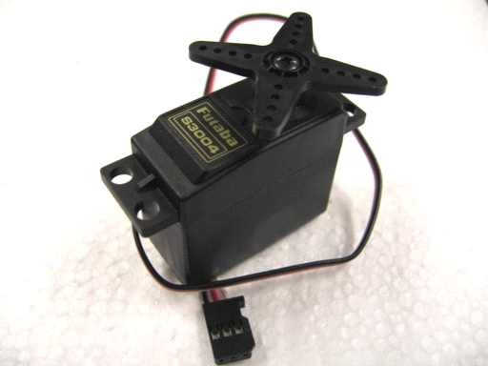

Figure 4.5: The Servomotor

**4.3.1 Force Sensitive Resistor (FSR):**

A force-sensing resistor is a material whose resistance changes when a force or pressure is applied. They are also known as "force-sensitive resistor" and are sometimes referred to as the "FSR".

Force-sensing resistors consist of a conductiveHYPERLINK "http://en.wikipedia.org/wiki/Conductive_polymer" pHYPERLINK "http://en.wikipedia.org/wiki/Conductive_polymer"olymer, which changes resistance in a predictable manner following application of force to its surface. They are normally supplied as a polymer sheet or ink that can be applied by screen printing. The sensing film consists of both electrically conducting and non-conducting particles suspended in matrix. The particles are sub-micrometre sizes and are formulated to reduce the temperature dependence, improve mechanical properties and increase surface durability. Applying a force to the surface of the sensing film causes particles to touch the conducting electrodes, changing the resistance of the film.

As with all resistive based sensors, force-sensing resistors require a relatively simple interface and can operate satisfactorily in moderately hostile environments. Compared to other force sensors, the advantages of FSRs are their size (thickness typically less than 0.5 mm), low cost and good shock resistance. A disadvantage is their low precision: measurement results may differ 10% and more.

Force-sensing resistors are commonly used to create pressure-sensing "buttons" and have applications in many fields, including musical instruments, car occupancy sensors, Foot pronation systems and portable electronics.

Resistance range: Infinite/open circuit (no pressure), 100KΩ (light pressure) to 200Ω

(max. pressure).

Force range: 0 to 20 lb. (0 to 100 Newtons) applied evenly over the 0.125 sq in surface area.

Power supply: Uses less than 1mA of current (depends on any pull-up/down resistors used and supply voltage).

FSRs are sensors that allow you to detect physical pressure, squeezing and weight. They are simple to use and low cost. A force-sensing resistor is a material whose resistance changes when a force or pressure is applied. They are also known as "force-sensitive resistor" and are sometimes referred to as the "FSR". This FSR will vary its resistance depending on how much pressure is being applied to the sensing area.

Force-sensing resistors consist of a conductive polymer, which changes resistance in a predictable manner following application of force to its surface. They are normally supplied as a polymer sheet or ink that can be applied by screen printing. The sensing film consists of both electrically conducting and non-conducting particles suspended in matrix. The particles are sub-micrometre sizes and are formulated to reduce the temperature dependence, improve mechanical properties and increase surface durability. Applying a force to the surface of the sensing film causes particles to touch the conducting electrodes, changing the resistance of the film.

As with all resistive based sensors, force-sensing resistors require a relatively simple interface and can operate satisfactorily in moderately hostile environments. Compared to other force sensors, the advantages of FSRs are their size (thickness typically less than 0.5 mm), low cost and good shock resistance. A disadvantage is their low precision: measurement results may differ 10% and more.

Force-sensing resistors are commonly used to create pressure-sensing "buttons" and have applications in many fields, including musical instruments, car occupancy sensors, Foot pronation systems and portable electronics. The Force Sensitive resistor or FSR is one of those parts that fills bins in interaction design labs across the world. In the code given bellow we are initializing force sensitive resistor to analog pin A0 and A1 of Arduino and assigning the initial force as 0 for fsr1 and fsr2 as force 1 and force 2.

The easiest way to measure a resistive sensor is to connect one end to Power and the other to a **pull-down** resistor to ground. Then the point between the fixed pulldown resistor and the variable FSR resistor is connected to the analog input of a microcontroller such as an Arduino. The FSR is made of 2 layers separated by a spacer. The more one presses, the more of those Active Element dots touch the semiconductor and that makes the resistance go down. FSRs are basically a resistor that changes its resistive value (in ohms Ω) depending on how much it is pressed. While FSRs can detect weight, they're a bad choice for detecting exactly how many pounds of weight are on them.

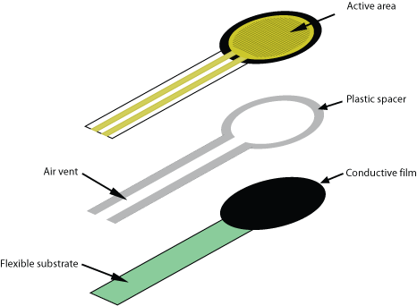

Figure 4.6: The Force Sensing Resistor (FSR)

The analog read on your Arduino is basically a voltage meter. At 5V (its max) it will read 1023, and at 0v it will read 0. So, we can measure how much voltage is on the FSR using the analogRead and we will have our force reading. The amount of that 5V that each part gets is proportional to its resistance. So, if the FSR and the resistor have the same resistance, the 5V is split evenly (2.5V) to each part. But if the FSR is pressed on hard, reading only 1K of resistance, the 10K resistor is going to soak up 10 times as much of that 5V. So, the FSR would only get .45V. And if something is barely pressing on it, the FSR may be 40K of resistance, so the FSR will soak up 4 times as much of that 5V as the 10K resistor. So, the FSR would get 4V. The FSR changes its resistance with force. It ranges from near infinite when not being touched, to under 300ohms when pressed hard. So, we can measure that change using one of the Arduino’s analog inputs. But to do that we need a fixed resistor (not changing) that we can use for that comparison (We are using a 10K resistor). This is called a voltage divider and divides the 5v between the FSR and the resistor. This FSR will vary its resistance depending on how much pressure is being applied to the sensing area. When there is no pressure, the sensor looks like an infinite resistor (open circuit), as the pressure increases, the resistance goes down. It is important to notice that the graph isn't linear (it’s a log/log graph) and that at especially low force measurements it quickly goes from infinite to 100KΩ.

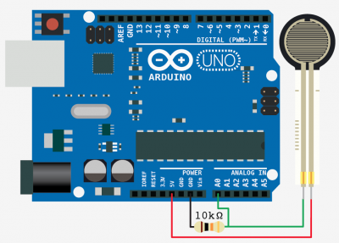

Figure 4.7: FSR connected to Arduino

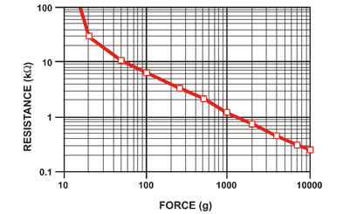

Figure 4.8: Resistance vs Force for FSR

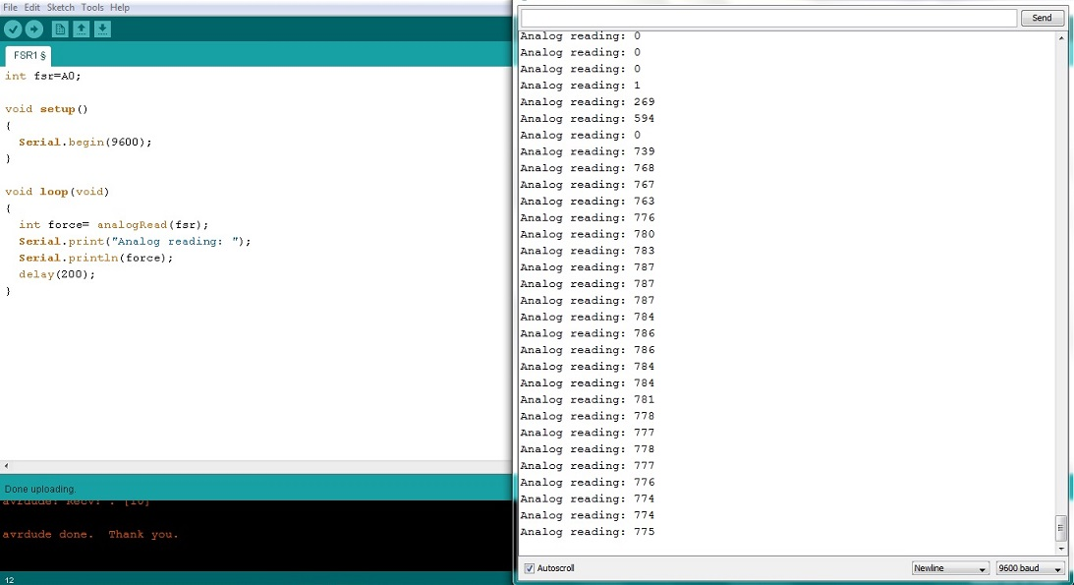

Figure4.9: Program written on FSR in Arduino

**4.3.3 Flex Sensor:**

Theoretical background:

Flex sensor is a flexible sensor which changes its output when it is bent or when force is applied on it. This sensor has two output wires. The resistance between these two wires varies when the sensor is bent or when subjected to a force. Hence this sensor can be used as a flex sensor. When the sensor is kept straight with no force acting on it, it has resistance of around 10 k ohms. When sensor is bend either way value of resistance between these two wires depends on the amount of bending.

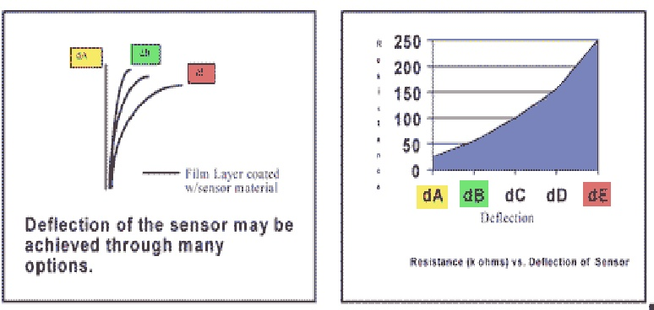

Figure4.9: Resistance dependence on deflection

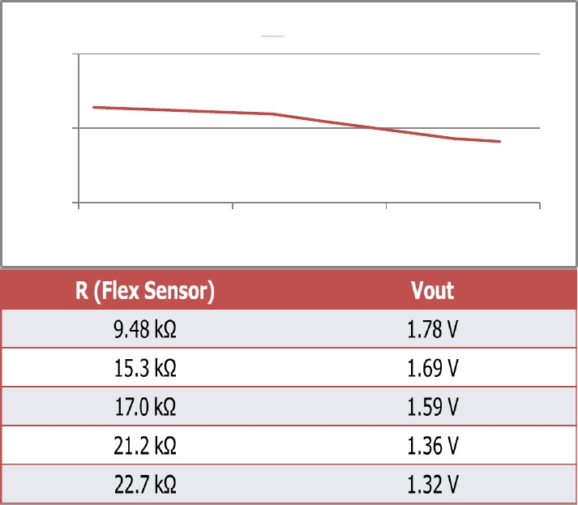

Figure 4.10: Voltage at various resistance

Electrical Characteristics:

Resistance range: 1.5-40 k ohms

Temperature range: -35 to+80 degree centigrade

Voltage range: 5 to 12v

Various sensor technologies are used to capture physical data such as bending of fingers. The flex sensors are the type of sensors that are used to capture the data of bending of fingers in the form of resistance. Flex sensors are the sensors that change the resistance depending upon the amount of bend on the sensor. They convert the change in bend to electrical resistance – the more the bend, the more is the resistance. They are usually in the form of thin strips from 1”- 5” inches long that vary in resistance. They can be made uni-directional or bi-directional.

Flex sensors are analog resistors. They function as analog voltage regulators. Inside the flex sensor carbon resistive elements within a thin substrate are present. More carbon means less resistance.

When the sbstrate is bent, the sensor produces a resistance output relative to the bend radius. These are used in robotics to determine the joint movements, bio-metrics, gaming gloves (incorporated onto a glove to make a virtual rality glove) etc.

Flex sensors are sensors that change in resistance with the amount of bend in sensors. Flex sensor are analog resistor. They work as variable voltage divider. Inside flex sensor is carbon resistive element within a thin flexible substrate. More carbon means more resistance. When the substrate is bent the sensor produces a resistance output relative to bend radius. They convert the change in bend to electrical resistance the more the bend the more the amount of electrical resistance.

A voltage divider is a simple circuit which turns a large voltage into a smaller one. Using just two series resistors and an input voltage, we can create an output voltage that is a fraction of the input. Voltage dividers are one of the most fundamental circuits in electronics, in other words. In electronics, a voltage divider (also known as a potential divider) is a passive linear circuit that produces an output voltage (Vout) that is a fraction of its input voltage (Vin). Voltage division is the result of distributing the input voltage among the components of the divider. A simple example of a voltage divider is two resistors connected in series, with the input voltage applied across the resistor pair and the output voltage emerging from the connection between them. Resistor voltage dividers are commonly used to create reference voltages, or to reduce the magnitude of a voltage so it can be measured and may also be used as signal attenuators at low frequencies.

For direct current and relatively low frequencies, a voltage divider may be sufficiently accurate if made only of resistors; where frequency response over a wide range is required (such as in an oscilloscope probe), a voltage divider may have capacitive elements added to compensate load capacitance. In electric power transmission, a capacitive voltage divider is used for measurement of high voltage. In life it's important to be flexible. But what do you do if you want to measure how flexible an object is? You use a flex sensor. A flex sensor uses carbon on a strip of plastic to act like a variable resistor or potentiometer but instead of changing the resistance by turning a knob you change it by flexing (bending) the component. We use a "voltage divider" again to detect this change in resistance. The sensor bends in one direction and the more it bends the higher the resistance gets -- it has a range from about 10K ohm to 35K ohm. In this circuit we will use the amount of bend of the flex sensor to control the position of a servo.

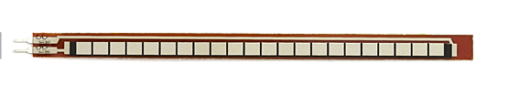

Figure 4.11: The Flex Sensor

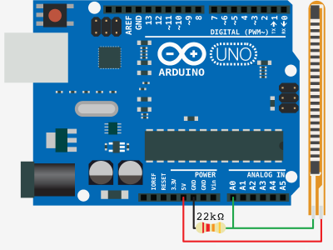

Figure 4.12 : flex sensor with arduino

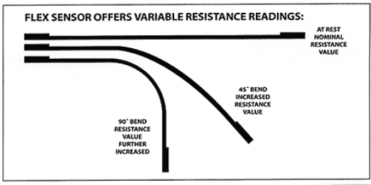

Figure 4.13: Variable resistance of flex sensor

The flex sensor is basically a variable resistor that reacts to bends. Unbent it measures about 22KΩ, to 40KΩ when bend 180º. Note that the bend is only detected in one direction and the reading can be a bit shaky, so you will have best results detecting changes of at least 10º.

Also, make sure you don’t bend the sensor at the base as it won’t register as a change, and could break the leads. Always tape some thick board to the base of it to make it won’t bend there. The flex sensor changes its resistance when flexed so we can measure that change using one of the Arduino’s analog pins. But to do that we need a fixed resistor (not changing) that we can use for that comparison (We are using a 22K resistor). This is called a voltage divider and divides the 5v between the flex sensor and the resistor. The analog read on your Arduino is basically a voltage meter, at 5V (its max) it would read 1023, and at 0v it read 0. So we can measure how much voltage is on the flex sensor using the analogRead and get the reading.

The amount of that 5V that each part gets is proportional to its resistance. So, if the flex sensor and the resistor have the same resistance, the 5V is split evenly (2.5V) to each part. Just pretend that the sensor was reading only 1.1K of resistance, the 22K resistor is going to soak up 20 times as much of that 5V. The flex sensor would only get .23VAnd if we roll the flex sensor around a tube, the flex sensor may be 40K or resistance, so the flex sensor will soak up 1.8 times as much of that 5V as the 22K resistor. Flex sensors are widely used in various applications such as – Automotive controls, Medical Devices, Fitness Products, Virtual Reality gaming consoles, Animatronics, Robotics, etc. Flex sensors are another type of variable resistor, they can be wired up in exactly the same way as the light sensitive and pressure sensitive resistors

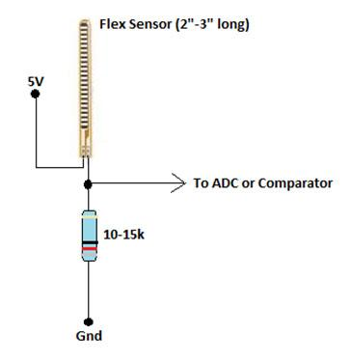

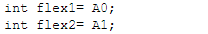

In above commands we are initializing the two flexes, flex1 and flex 2 to analog pins A0 and A1 of Arduino board.

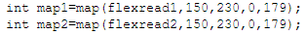

In above code we are denoting that for ranges of 150 to 230 the flex sensor will be working the best and for that value of resistance the motor will rotate within the angle 0 degree to 180 degrees. The bend sensor technology has many potential applications in the consumer product sector it is to emphasis the functionality, reliability, quality and user convenience. Various sensor technologies are used to capture physical data such as bending of fingers. The flex sensors are the type of sensors that are used to capture the data of bending of fingers in the form of resistance. Flex sensors are the sensors that change the resistance depending upon the amount of bend on the sensor. They convert the change in bend to electrical resistance – the more the bend, the more is the resistance. They are usually in the form of thin strips from 1”- 5” inches long that vary in resistance. They can be made uni-directional or bi-directional.

Flex sensors are analog resistors. They function as analog voltage regulators. Inside the flex sensor carbon resistive elements within a thin substrate are present. More carbon means less resistance. When the substrate is bent, the sensor produces a resistance output relative to the bend radius. These are used in robotics to determine the joint movements, bio-metrics, gaming gloves (incorporated onto a glove to make a virtual reality glove) etc.

Flat Resistance: 25K Ohms

Resistance Tolerance: ±30%

Bend Resistance Range: 45K to 125K Ohms (depending on bend radius)

Power Rating: 0.50 Watts continuous. 1-Watt Peak

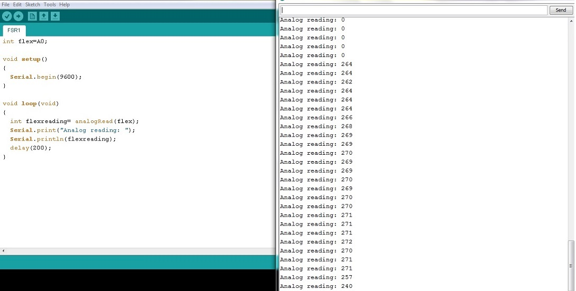

**4.5: Linear Resonant Actuator:**

A linear actuator is an actuator that creates motion in a straight line, in contrast to the circular motion of a conventional electric motor. If you have an application that requires a durable vibration, or a high confidence Mean time between failure (it is the predicted elapsed time between inherent failures of a system during operation) rating, consider our Linear Resonant Actuator vibration motors as an alternative to long life brushless vibration motors.

Linear actuators are used in machine tools and industrial machinery, in computer peripherals such as disk drives and printers, in valves and dampers, and in many other places where linear motion is required. A linear actuator is an [actuator](http://en.wikipedia.org/wiki/Actuator) that creates motion in a straight line, in contrast to the circular motion of a conventional [electric motor](http://en.wikipedia.org/wiki/Electric_motor). If you have an application that requires a durable vibration, or a high confidence Mean time between failure (it is the predicted elapsed time between inherent failures of a system during operation) rating, consider our Linear Resonant Actuator vibration motors as an alternative to long life brushless vibration motors.

Linear actuators are used in machine tools and industrial machinery, in computer peripherals such as disk drives and printers, in valves and dampers, and in many other places where linear motion is required.

These days miniature vibrating motors are used in a wide range of products, like tools, scanners, medical instruments, GPS, and control sticks. Vibrator motors are also the main actuators for **haptic feedback** which is an **inexpensive way to increase a product's value and differentiate it from competition.**

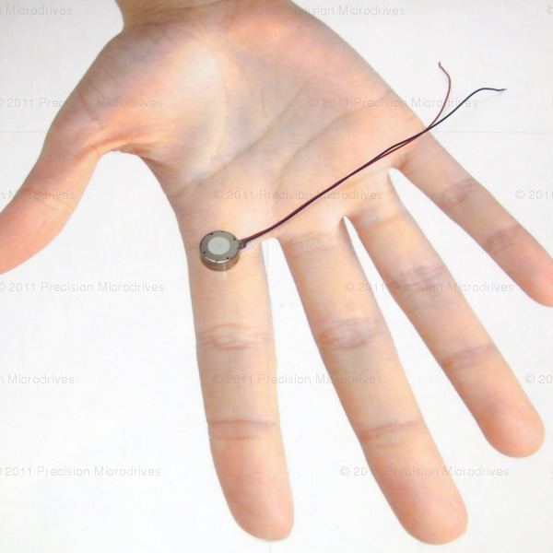

Figure: 4.15: Vibrator on human hands

A magnetic field is generated by the voice coil which interacts with the magnet & mass, which are suspended on a spring. As the magnetic field varies with the applied drive signal, the magnet & mass are moved up and down as they interact with the spring.

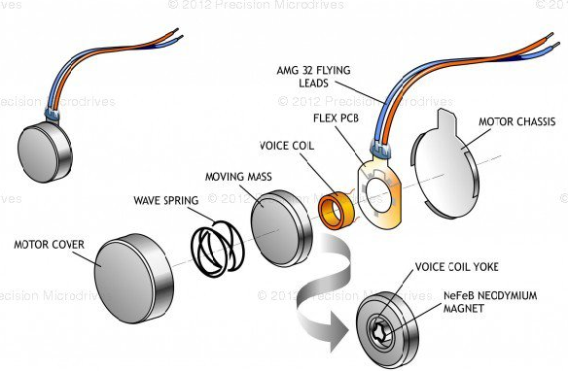

Figure 4.16: The Linear Resonant Actuator

The Linear Resonant Actuator are used in many hand held and touch screen devices. They are used to communicate information to users by sense of touch. When audio and visual sensing is not available this additional method of communication can become helpful, or it can supplement the other senses. A torque wrench reaching the correct torque can send a controlled vibration to the user to communicate this to them. A controlled vibration alerting a soldier of an enemy within a certain radius can be helpful as for visual or audio alert going off which could compromise their strategy. There may be many uses for the hearing impaired. Such as controlled vibration from an actuator that is placed within a pillow serving as an alarm device that can be set to wake up.

Using a microcontroller such as the Arduino Uno can support the user interface and make it easy to store and select advanced vibration outputs. Microcontrollers cannot provide enough current to drive LRA’s so there must be an additional driving circuit.

**5. APPLICATIONS**

Many operations in hazardous environments such as nuclear stations, mines, polluted environments, war zones, or in remote environments such as the space, or underwater are difficult or impossible to be carried out directly by humans or even by fully autonomous robots. These robots must rely on human operator expertise to carry out manipulation tasks, which require a higher level of intelligence.

**Military purpose:**

Bomb diffusing is very difficult & it may put life in risk if directly human diffuse bomb. For the safety of human life, Robots are involved in the field of bomb diffusing. This project aims to control the robot by means of haptic technology. The main objective of this project is to design and develop the robotic arm using haptic technology for bomb diffusing applications. To accomplish these objectives, we designed a master-slave robot arm in which motion tilt tracks a human operator's arm motion including open-close hand tracking by the end-effector. For this case we are using 2 accelerometric sensors as motion tracking sensors & potentiometer as end effector. To avoid the risk, haptic technology is introduced in the robot arm to diffuse the bomb. We are going to use robotic arm in our project. Before there are so many methods followed to diffuse bombs, like by the humans directly diffusing it is very risk. so, by using robot’s arms in different technologies like radio control, remote control, voice control, etc., The difficulties in the above discussed technologies is remote control has problems like it work as per range, radio control has problems in signals, voice control has it may detect other voices.

So, we are using haptic technology to overcome these difficulties. Without risking human life or limb, this research has applications in many areas, but we are using for bomb diffusing process. Haptic technology is very useful in future to organize robots as like as human movements. This is better than automatic robots. The challenge for soldiers on field is to maintain and monitor visual and auditory information channels, and at the same time having enough awareness of the environment and the situation the soldier is in. The soldiers can focus more at different obstacles and environment awareness when receiving tactile signals than when receiving visual hand signals. Security issues must be considered; the soldiers must get reliable information via the haptic applications. The technology that delivers the information must be robust and work in extreme conditions. Even if the technology works fine, it is as important to make sure, that the messages sent are clear to be understood in difficult conditions. Reliability of the information source is essential; in case of a combat situation, if the enemy could feed wrong information to the soldiers’ tactile displays, the results could be disastrous. If the tactile signals are not reliable enough for some reasons, it could be well worth having a look if tactile signals could be used as attention cues; the tactile information would just deliver a message about more specific information somewhere else.

**Medical Engineering:**

One of the technologies which aid the surgeons to perform even most complicated surgeries successfully is Virtual Reality (VR). Even though VR is employed to carry out operations the surgeon's attention is one a most important parameter. If he commits any mistakes it may lead to a dangerous end. So, one may think of a technology that reduces burdens of surgeon by providing an efficient interaction to surgeon than VR. Now our dream came to reality by means of technology called HAPTIC TECHNOLOGY Haptic is science of applying tactile sensation to human interaction with computers. In our paper we have discussed basic concepts behind haptic along with haptic device and how these devices are interacted to produce sense of touch & force feedback mechanisms Haptic generally describes touch feedback, which may include kinaesthetic (force) and cutaneous (tactile) feedback.

In manual minimally invasive surgery (MIS), surgeons feel the interaction of the instrument with the patient via a long shaft, which eliminates tactile cues and masks force cues. Some studies have linked the lack of significant haptic feedback in MIS to increased intra-operative injury. In teleoperated robot-assisted minimally invasive surgery (RMIS), all-natural haptic feedback is eliminated because the surgeon no longer manipulates the instrument directly. The lack of effective haptic feedback is often reported by surgeons and robotics researchers alike to be a major limitation to current RMIS systems.

**In surgery**: A primary application area for haptics has been in surgical simulation and medical training. Haptic rendering algorithms detect collisions between surgical instruments and virtual organs and render organ-force responses to users through haptic interface devices. For the purpose of haptic rendering, we've conceptually divided minimally invasive surgical tools into two generic groups based on their functions. For the purposes of haptic rendering of tool-tissue interactions, a ray-based rendering, in which the probe and forceps are modelled as connected line segments. Modelling haptic interactions between a probe and objects using this line-object collision detection and response has several advantages over existing point based techniques, in which only the tip point of a haptic device is considered for touch interactions'.

Grouping of surgical instruments for simulating tool-tissue interactions:

Group A includes long, thin, straight probes.

Group B includes tools for pulling, clamping, and cutting soft tissue.

• Users feel torques if a proper haptic device is used. For example, the user can feel the coupling moments generated by the contact forces at the instrument tip and forces at the trocar pivot point.

• Users can detect side collisions between the simulated tool and 3D models of organs.

• Users can feel multiple layers of tissue if the ray representing the simulated surgical probe is virtually extended to detect collisions with an organ's internal layers. This is especially useful because soft tissues are typically layered, each layer has different material properties, and the forces/torques reflected to the user depends on the laparoscopic tool's orientation.

• Users can touch and feel multiple objects simultaneously. Because laparoscopic instruments are typically long slender structures and interact with multiple objects (organs, blood vessels, surrounding tissue, and so on) during a MIS (Minimally Invasive Surgery), ray-based rendering provides a more natural way than a purely point-based rendering of tool-tissue interactions. To simulate haptic interactions between surgical material held by a laparoscopic tool (for example, a catheter, needle, or suture) and a deformable body (such as an organ or vessel), a combination of point- and ray-based haptic rendering methods are used.

**Catheter insertion task**:

In case of a catheter insertion task shown above, the surgical tools using line segments and the catheter using a set of points uniformly distributed along the catheter's centre line and connected with springs and dampers. Using our point based haptic rendering method; the collisions between the flexible catheter and the inner surface of a flexible vessel are detected to compute interaction forces.

The concept of distributed particles can be used in haptic rendering of organ-organ interactions (whereas a single point is insufficient for simulating organ-organ interactions, a group of points, distributed around the contact region, can be used) and other minimally invasive procedures, such as bronchoscope and colonoscopy, involving the insertion of a flexible material into a tubular body.

**Future medical applications:**

One currently developing medical innovation is a central workstation used by surgeons to perform operations remotely. Local nursing staff set up the machine and prepare the patient, and rather than travel to an operating room, the surgeon becomes a telepresence. This allows expert surgeons to operate from across the country, increasing availability of expert medical care. Haptic technology provides tactile and resistance feedback to surgeons as they operate the robotic device. As the surgeon makes an incision, they feel ligaments as if working directly on the patient

**Art:**

Touching is not limited to feeling but allows interactivity in real-time with virtual objects. Thus, haptics is used in virtual arts, such as sound synthesis or graphic design and animation. The haptic device allows the artist to have direct contact with a virtual instrument that produces real-time sound or images. For instance, the simulation of a violin string produces real-time vibrations of this string under the pressure and expressiveness of the bow (haptic device) held by the artist. This can be done with physical modelling synthesis.

Designers and modellers may use high-degree-of-freedom input devices that give touch feedback relating to the "surface" they are sculpting or creating, allowing faster and more natural workflow than traditional methods.

**Holographic interaction:**

Researchers at the University of Tokyo are working on adding haptic feedback to holographic projections the feedback allows the user to interact with a hologram and receive tactile responses as if the holographic object were real. The research uses ultrasound waves to create acoustic radiation pressure, which provides tactile feedback as users interact with the holographic object. The haptic technology does not affect the hologram, or the interaction with it, only the tactile response that the user perceives. The researchers posted a video displaying what they call the Airborne Ultrasound Tactile Display. As of 2008 the technology was not ready for mass production or mainstream application in industry, but was quickly progressing, and industrial companies showed a positive response to the technology. This example of possible future application is the first in which the user does not have to be outfitted with a special glove or use a special control.

**Robotics:**

The Shadow Hand uses the sense of touch, pressure, and position to reproduce the strength, delicacy, and complexity of the human grip. The SDRH was developed by Richard Greenhill and his team of engineers in London as part of The Shadow Project, now known as the Shadow Robot Company, an on-going research and development program whose goal is to complete the first convincing artificial humanoid. An early prototype can be seen in NASA's collection of humanoid robots, or robonauts. The Shadow Hand has haptic sensors embedded in every joint and finger pad, which relay information to a central computer for processing and analysis. Carnegie Mellon University in Pennsylvania and Bielefeld University in Germany found The Shadow Hand to be an invaluable tool in advancing the understanding of haptic awareness, and in 2006 they were involved in related research. The first PHANTOM, which allows one to interact with objects in virtual reality through touch, was developed by Thomas Massie while a student of Ken Salisbury at MIT.

**Teleoperators and simulators:**

Teleoperators are remote controlled robotic tools—when contact forces are reproduced to the operator, it is called haptic teleoperation. The first electrically actuated teleoperators were built in the 1950s at the Argonne National Laboratory by Raymond Goertz to remotely handle radioactive substances. Since then, the use of force feedback has become more widespread in other kinds of teleoperators such as remote controlled underwater exploration devices.

When such devices are simulated using a computer (as they are in operator training devices) it is useful to provide the force feedback that would be felt in actual operations. Since the objects being manipulated do not exist in a physical sense, the forces are generated using haptic (force generating) operator controls. Data representing touch sensations may be saved or played back using such haptic technologies. Haptic simulators are used in medical simulators and flight simulators for pilot training.

Many newer generation console controllers and joysticks feature built in feedback devices too, including Sony's Dual Shock technology. Some automobile steering wheel controllers, for example, are programmed to provide a "feel" of the road. As the user makes a turn or accelerates, the steering wheel responds by resisting turns or slipping out of control.

**6. PROGRAMMING**

Arduino is an open-source computer hardware and software company, project and user community that designs and manufactures kits for building digital devices and interactive objects that can sense and control the physical world. Arduino is a tool for making computers that can sense and control more of the physical world than your desktop computer. It's an open-source physical computing platform based on a simple microcontroller board, and a development environment for writing software for the board. For programming the microcontrollers, the Arduino platform provides an integrated development environment (IDE) based on the Processing project, which includes support for [C](http://en.wikipedia.org/wiki/C_programming_language) and C++ programming languages.

The Arduino integrated development

t environment (IDE) is a cross- HYPERLINK "http://en.wikipedia.org/wiki/Cross-platform"platform application written in [Java](http://en.wikipedia.org/wiki/Java_(programming_language)), and derives from the IDE for the Processing programming language and the Wiring projects. It is designed to introduce programming to artists and other newcomers unfamiliar with software development. It includes a code editor with features such as syntax highlighting, brace matching, and automatic indentation, and is also capable of compiling and uploading programs to the board with a single click.

The features of Arduino software are Cross-platform means the Arduino software runs on Windows, Macintosh OSX, and Linux operating systems. Most microcontroller systems are limited to Windows. Simple, clear programming environment, the Arduino programming environment is easy-to-use for beginners, yet flexible enough for advanced users to take advantage of as well. Open source and extensible software, the Arduino software is published as open source tools, available for extension by experienced programmers. The language can be expanded through C++ libraries, and people wanting to understand the technical details can make the leap from Arduino to the AVR C programming language on which it's based.

A program or code written for Arduino is called a "sketch". The Arduino IDE comes with a software library called "Wiring" from the original Wiring project, which makes many common input/output operations much easier. Users only need define two functions to make an executable cyclic executive program. The Arduino platform uses Atmel microcontrollers, Atmel's development environment, AVR Studio or the newer Atmel Studio, may also be used to develop software for the Arduino.

The transmitter transmits the values of resistance given by the flex sensors. These sensors are connected to the analog input pins. The vibrating motor rotates according to the values give by the force sensitive resistors. The ZIGBEE protocol is used to transfer this data from transmitter to receiver. The program given below describes the functioning of transmitter:

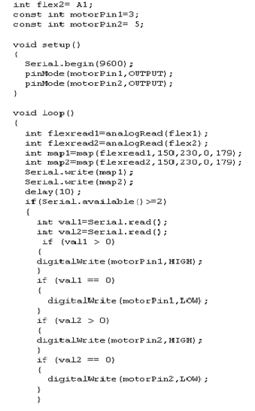

The receiver receives the values of resistance given by the flex sensors and transmits the resistance values of force resistive sensors. The servo motors operate according to the values of the flex sensors. The ZIGBEE protocol is used to transfer this data from receiver to transmitter. The program given below describes the functioning of receiver:

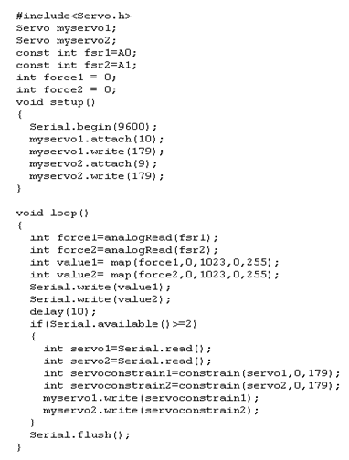

**RESULTS**

